* Social Evening (Seite 8; nochmals auf Barzahlung hinweisen) und ggf. how to get there (Seite 3; weiß aber nicht, ob das für die Cap San Diego wirklich nötig ist) -> Anja

Shorter:

The social evening will be held at Cap San Diego, which is a museum ship located at Überseebrücke in the Port of Hamburg. Please keep in mind that o**nly cash payment** is possible on the Cap San Diego.

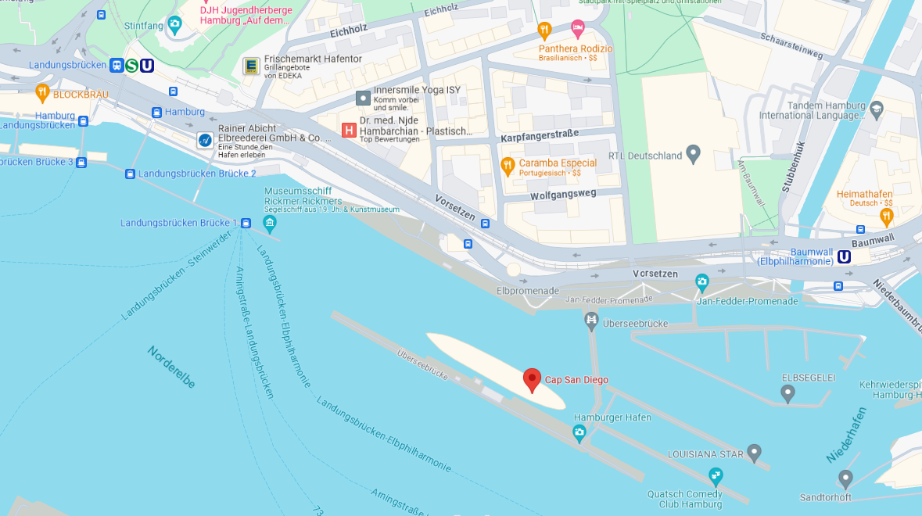

**How do I get to the social evening?**

**By Public Transport:**

* **S-Bahn:** S1 or S3 to Landungsbrücken (5-minute walk).
* **U-Bahn:** U3 to Baumwall (7-minute walk).
* **Bus:** Lines 111 and 112 to Landungsbrücken (5-minute walk).

**By MOIA:**

* **MOIA:** Book a shared ride via the MOIA app.

**By Stadtrad:**

* **Stadtrad:** Hamburg’s bike-sharing service, Stadttrad has stations throughout the city. Pick up a bike from any station and drop it off at Landungsbrücken. The first 30 minutes are free after registration.

**How do I get home later at night?**

**Night Buses:**

* **Night Bus Network:** Buses with a 600 numbers run all night. Check HVV app for routes.
* **S-Bahn and U-Bahn:** Most lines operate all night on Friday and weekends. Check the HVV app for schedules and routes.

**MOIA:**

* **MOIA:** Available late at night via the app.

**Taxi:**

* **Hansa Taxi:** +49 40 211211
* **Taxi Hamburg:** +49 40 666666
* **Taxiruf:** +49 40 441011
* **Das Taxi Hamburg:** +49 40 221122

**Stadtrad:**

* **Stadtrad:** Bikes available late at night.

Enjoy your evening and travel safely!